**7. Implement program for decomposing time series data into trend and seasonality**

| **EX.N0 : 7** | **Implement program for decomposing time series data into trend and seasonality** |
| --- | --- |
| **DATE : 07/04/2025** |

**AIM:**

To Implement program for decomposing time series data into trend and seasonality. **PROGRAM:**

import pandas as pd

import matplotlib.pyplot as plt

from statsmodels.tsa.seasonal import seasonal_decompose

'

file_path = r"C:\Users\heman\OneDrive\Desktop\abdul\TSA\EX 6\Crude Oil Prices Daily.xlsx"

df = pd.read_csv(file_path, parse_dates=['Date'], index_col='Date')

df.columns = df.columns.str.strip()

print("\n Available columns:", df.columns)

target_col = "Adj Close"

if target_col not in df.columns:

raise ValueError(f"'{target_col}' column not found in the dataset.")

ts = df[target_col].dropna()

result = seasonal_decompose(ts, model='additive', period=30)

plt.figure(figsize=(12, 10))

plt.subplot(411)

plt.plot(ts, label="Original", color='blue')

plt.title("Original Time Series")

plt.legend()

plt.subplot(412)

plt.plot(result.trend, label="Trend", color='orange')

plt.title("Trend Component")

plt.legend()

plt.subplot(413)

plt.plot(result.seasonal, label="Seasonality", color='green')

plt.title("Seasonal Component")

plt.legend()

plt.subplot(414)

plt.plot(result.resid, label="Residuals", color='red')

plt.title("Residual Component")

plt.legend()

plt.tight_layout()

plt.suptitle("Time Series Decomposition of Gold Price", fontsize=16, y=1.02) plt.show()

**OUTPUT:** 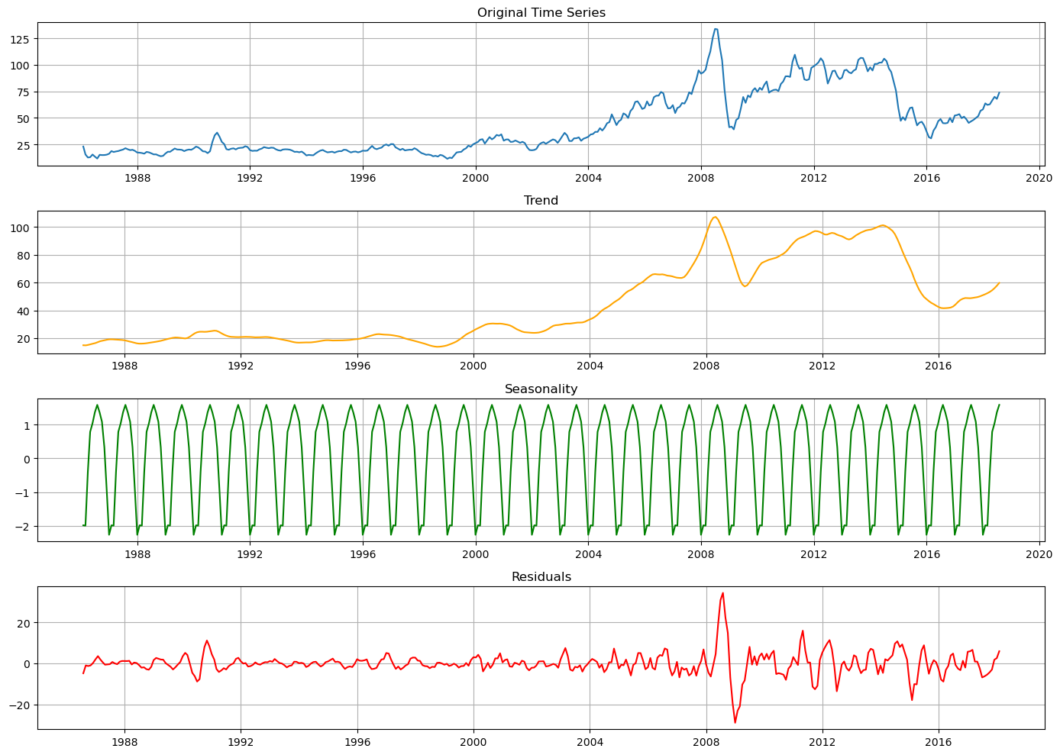

**RESULT:**

Thus, the program for Implement program for decomposing time series data into trend and seasonality is executed successfully.